January 2023 blog:

- We are really delighted to have been chosen as one of just five schools in the whole of the UK to be a Royal Horticultural Society Growing Champion.
This will involve making regular videos for the RHS’s digital channels, as well as sharing tips, experiences and advice for other schools on growing flowers and vegetables.
Our 86 pupils have also won a £100 National Garden Gift Voucher to thank us for contributing to what the RHS calls ‘this exciting national campaign’.

“Many congratulations on achieving your recent School Gardening Award (RHS Level 4),” writes Abbie Chadwick, Communications Officer, Schools and Groups at the RHS, “and we’d like to invite your school to be one of five growing champion schools across the UK for ‘The Big Seed Sow’, our new growing campaign, launching on 20th February … sharing your wealth of experience, knowledge and passion with other schools. The videos will document each season’s work - the challenges and happy accidents - your top tips and more.”
- Well, we are truly honoured and this is one of the most prestigious awards we’ve had in all our 175 years as a school. Well done everyone! This is particularly pleasing as we set such store at St Margaret’s on teaching the children to love nature and enjoy growing things. It’salso pretty dizzying to be part of such a tiny green elite!
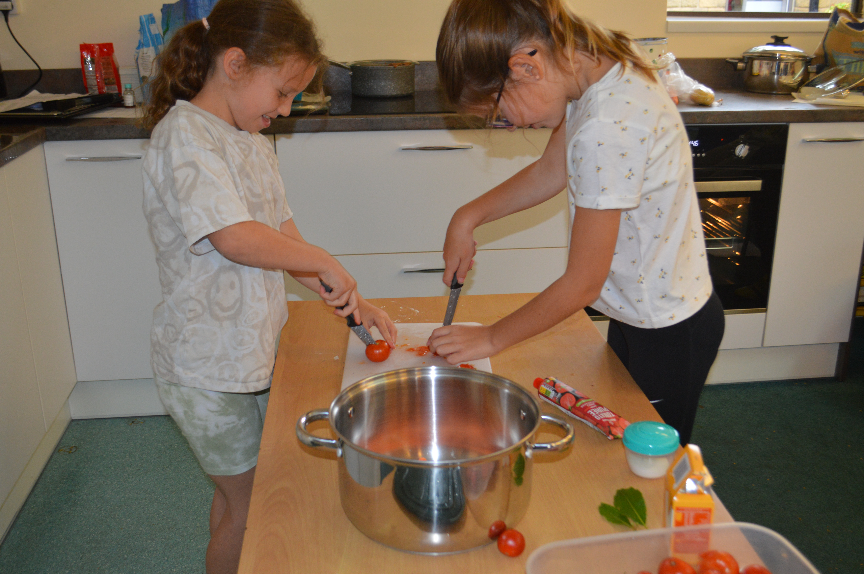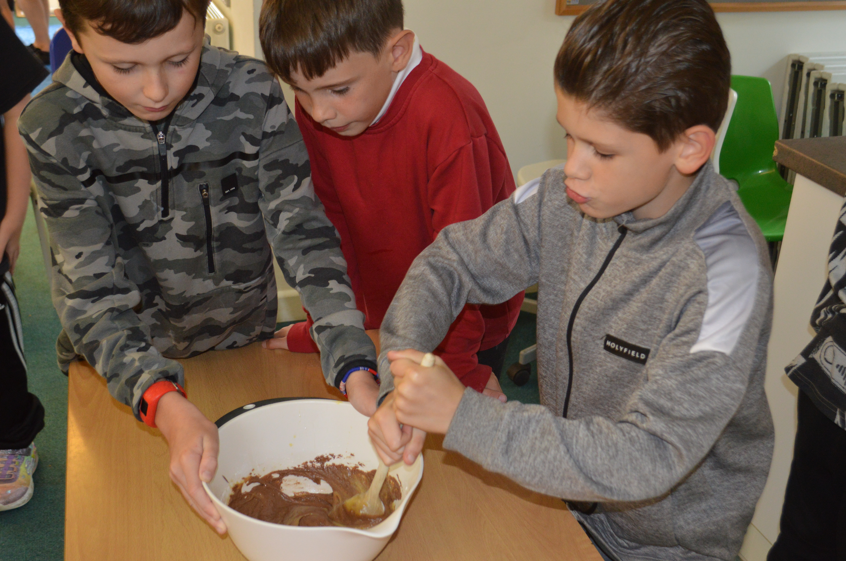
- We have been going through some intensive training this month sharing best practice working with the Cornerstone’s English Hub, looking to improve the pupils’ reading and writing.
- Likewise, we are training on Maths teaching with the Boolean Maths Hub to deepen our understanding of maths.
- Lastly, we should add that just before Christmas we had a virtual visit from Rabbi Shoshanna Boyd Gelfand to talk to the children about Hannukah, the Jewish Festival of Lights. This was part of our ethos of Inclusiveness and accepting all cultures, which lies at the very centre of our culture at the school.

