October 2022 Blog
This month was No Outsiders month – where we focused on making sure that everyone will always be welcome at our school, irrespective of colour or religion. So, it was wonderful to welcome the recognised expert on inclusivity, Andrew Moffatt, who is a teacher and founder of the charity No Outsiders. Its motto is Everyone different, Everyone welcome.
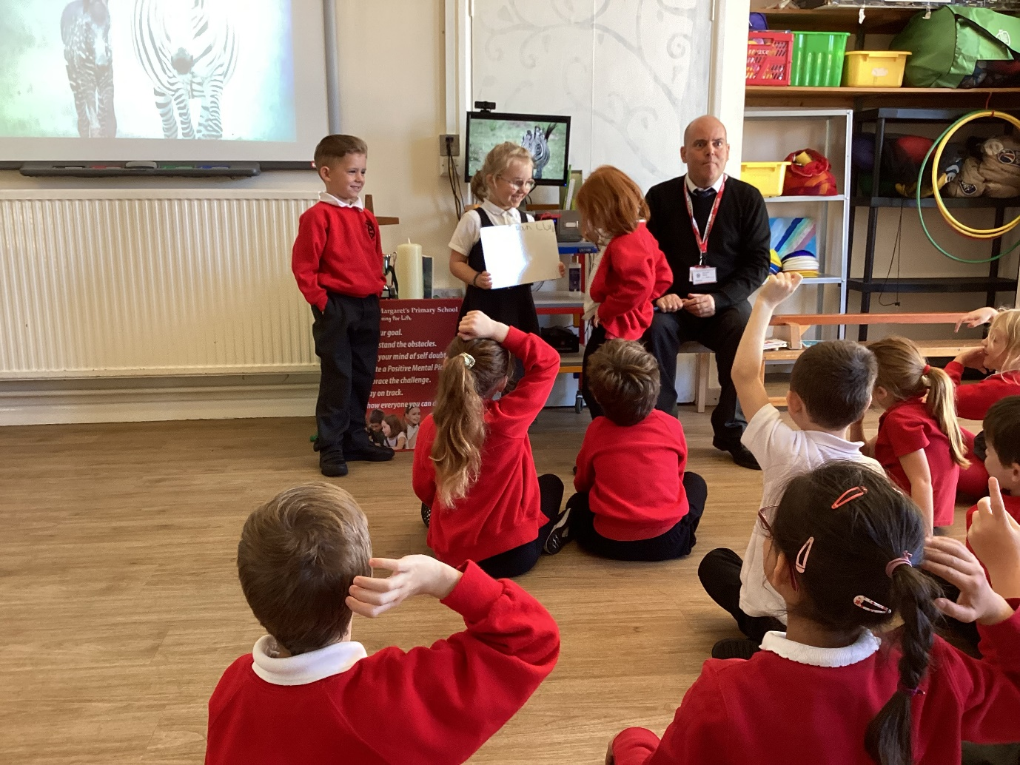
Andrew spent time with every class reading books on diversity and acceptance. I was really struck how our older pupils were informed and relaxed when talking about LGBTQ+ issues. We are a No Outsider School and await our plaque reading: Everyone’s different, Everyone’s welcome.
I’m delighted to report that we did very well in the cross-country meeting at the County Football Ground. Fighting a fierce wind, they all performed brilliantly.
We also competed in a football tournament at Bucklers Mead Secondary School, taking a mixed team which had never played together before. We reached the semi-final. Terrific!
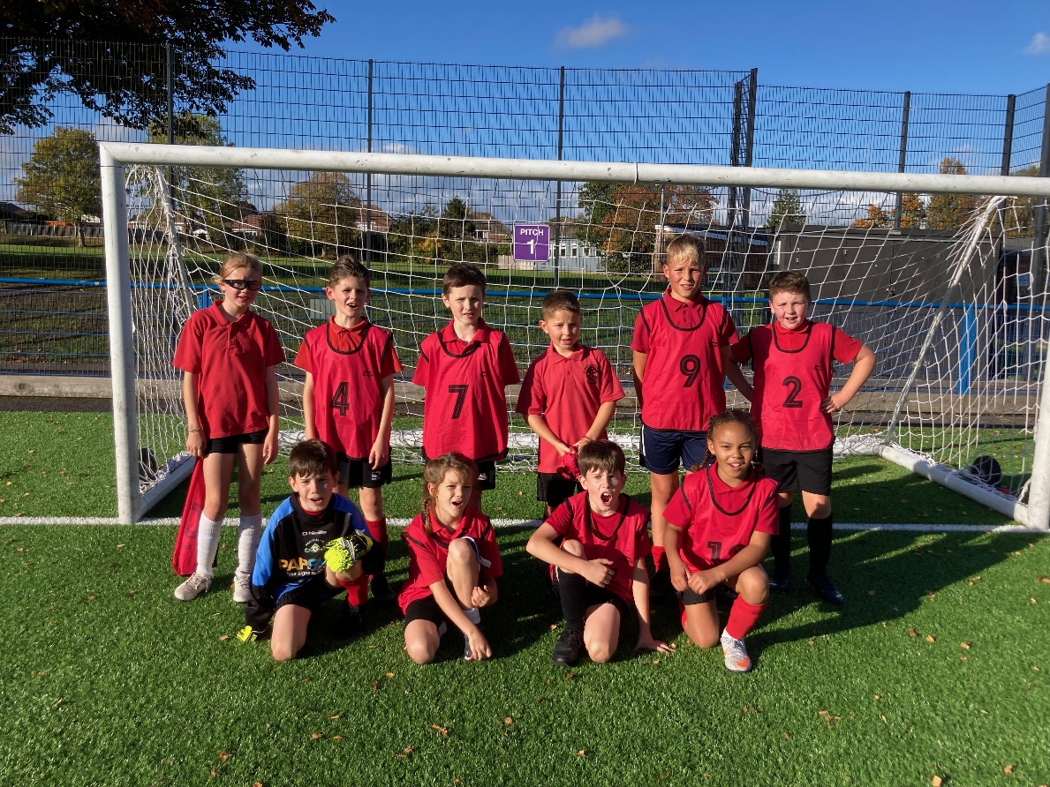
November 2022
Very happy that we have won a Local School Nature Grant. This will give us a year’s complimentary training on outdoor learning and play from the Learning from Landscape charity. It involves working outdoors, films and presentations and will really enrich the children’s experience of nature and growing things. Thank you, Mrs Anderton & Mrs Hallet for persisting with this, your determination won through!
The local Yeovale Rotary Club visited to plan some work in the grounds around the school. They had a tour of the school and then we discussed how they would be improving Explorer’s outside area. We are really grateful for their support and look forward to their visit.
We also welcomed this month a new Office Manager, Harriet Morgan, who is a great addition to our team. Harriet is from Yeovil and spent 17 years in NHS administration.
Lastly, the children have been busy preparing Christmas boxes for 50 elderly and vulnerable people in the village. They are also making individual cards and will deliver everything with carols in Christmas hats and jumpers on 8th December.

