September 2022 Blog

Great excitement to start the new school year! Two giant rabbits with massive ears and a gecko lizard visited our Discovery class (Nursery and Pre-School). 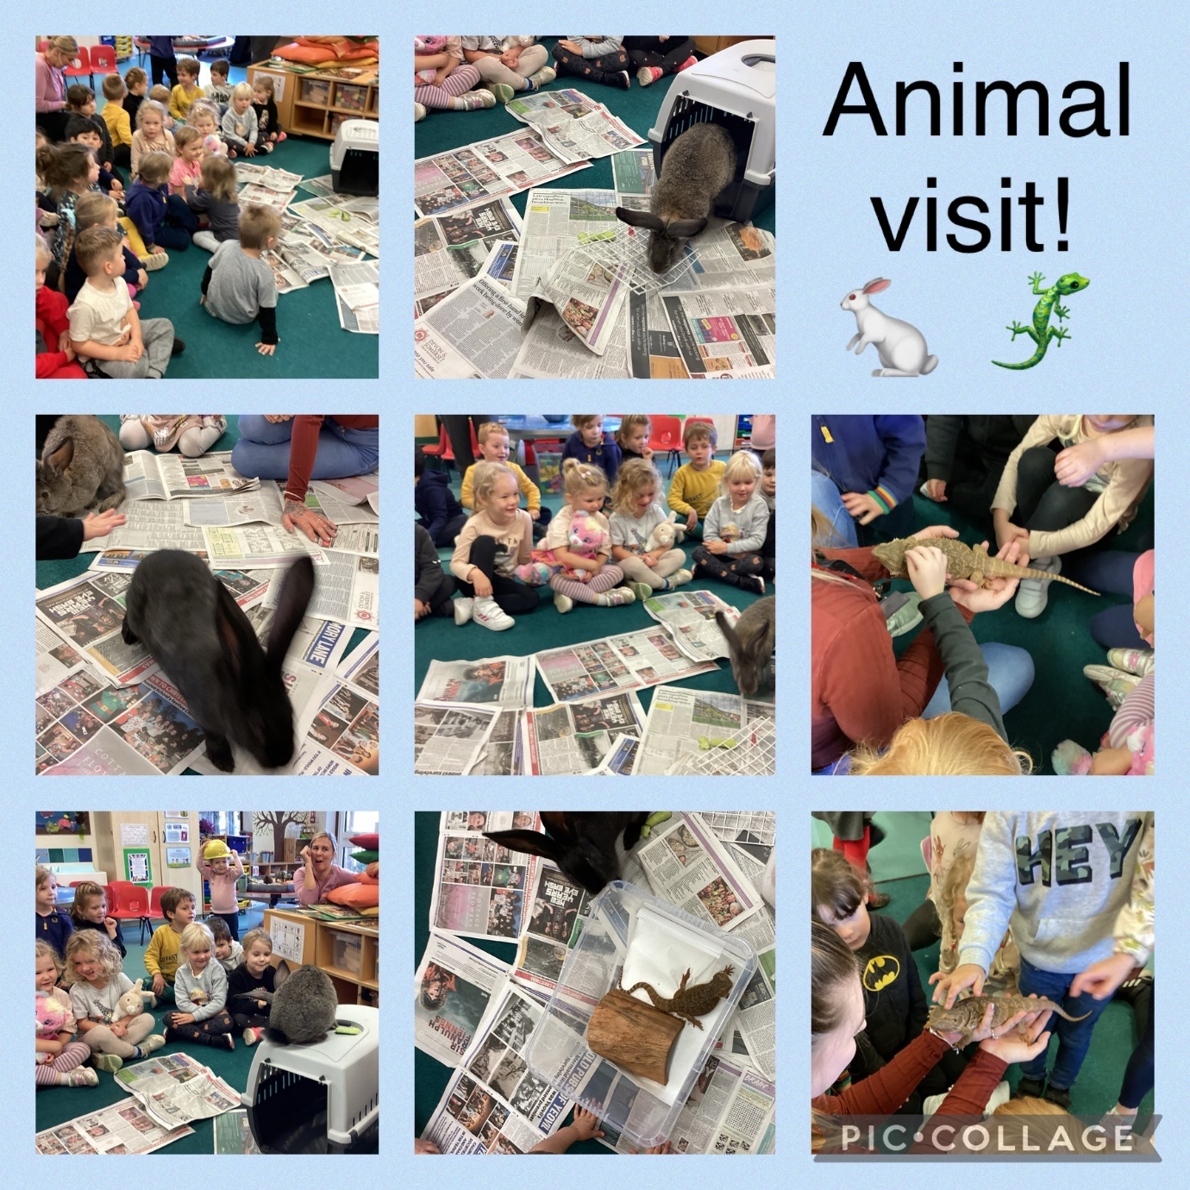
These belong to Primrose and her mum explained how to care for pets like this. Key things to remember: quiet voice, soft hands!
We had a Reading Morning where parents came in to take part in reading with the children and to understand how we teach this essential skill with phonics. We were delighted to see 95% attendance by parents, and it’s really encouraging to get such great support.
And the same can be said of the two Parents’ Evenings we held which were very well attended – the first face-to-face evenings in two years because of Covid.
Lastly, in September Discovery Class started an ambitious project on castles. To help understand the concept of an old building, they’ve started studying the many historic houses here in the village. Currently they are looking for the two former sites of our school which has existed since 1848.

Ends

